# **Shalin Bhattarai**

Assignment 3

# **Report on CSS Grid Layout and Responsive Design**

## **Introduction to CSS Grid Layout**

CSS Grid Layout is a two-dimensional layout system that allows developers to create complex and responsive web designs with ease. It enables the arrangement of elements in rows and columns

**Key Features of CSS Grid Layout:**

**Two-Dimensional  
Flexible Sizing**  
**Explicit and Implicit Grids**

**Description of Layout Changes at Different Breakpoints**

### **1. Desktop View (1024px and above)**

* **Header**: Fixed at the top with a wide layout accommodating a logo, company name, and quotes. The header remains expansive, allowing
* **Hero Section**: Full-screen image with text overlay, utilizing flexbox for center alignment. The product information is clearly displayed in a structured format.
* **Testimonials and Services**: Arranged in a grid layout with adequate spacing. Services are displayed side by side for easy comparison.
* **Footer**: Fixed at the bottom with navigation links spaced evenly.

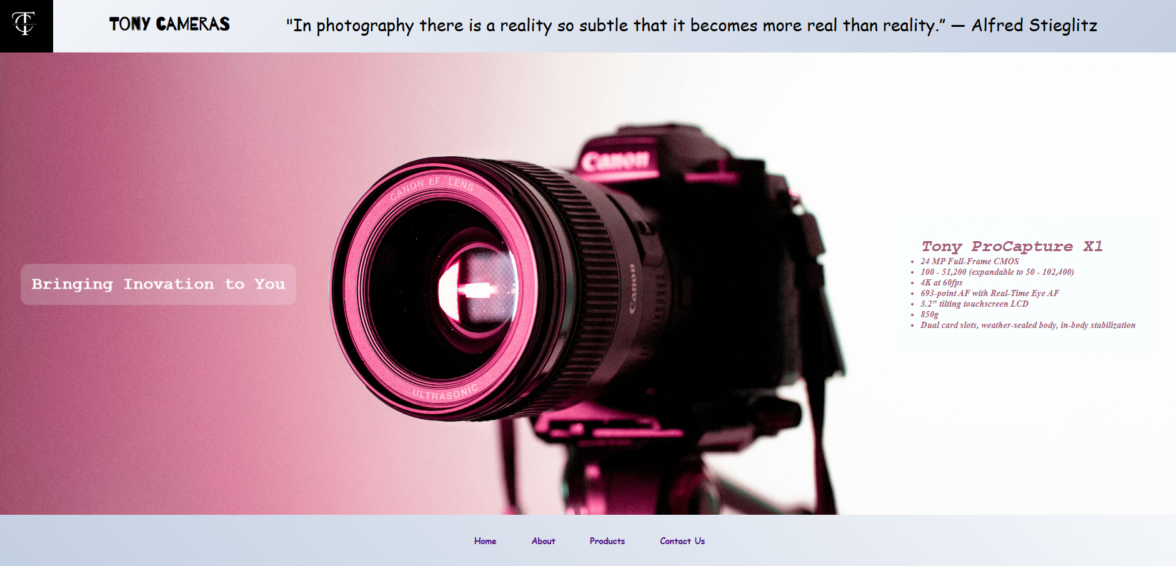

### **2. Tablet View (768px)**

* **Reduced height of header and footer. In many parts of the websites flex-direction from rows to columns was changed for example: in the hero section**

** changed into 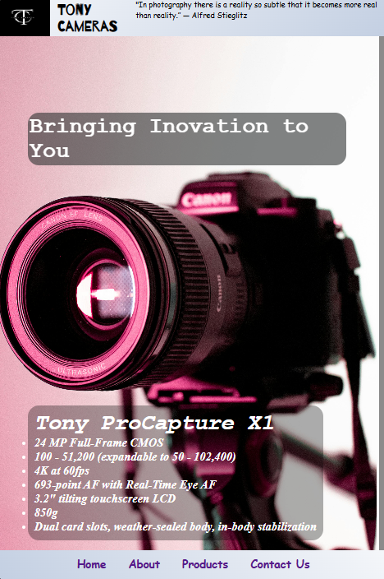 for tablet and mobile view**

**Font sizes were changed**

### **3. Mobile View (320px)**

Reduced font size, header and footer, flex direction changed in mobile view in services section for better navigation:

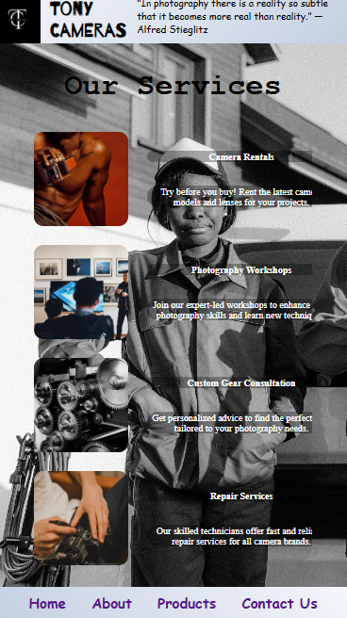

## **Screenshots of Each Page at Various Resolutions**

### **Index page**

Mobile:  
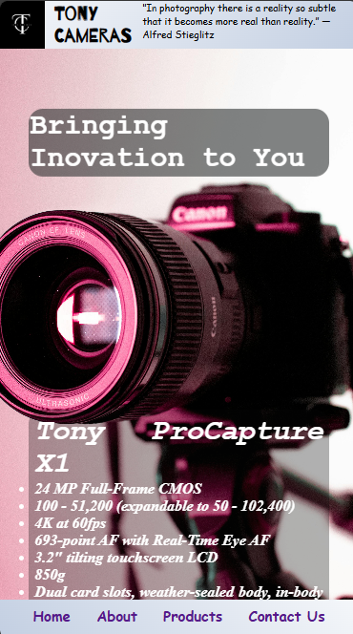

Tablet:  
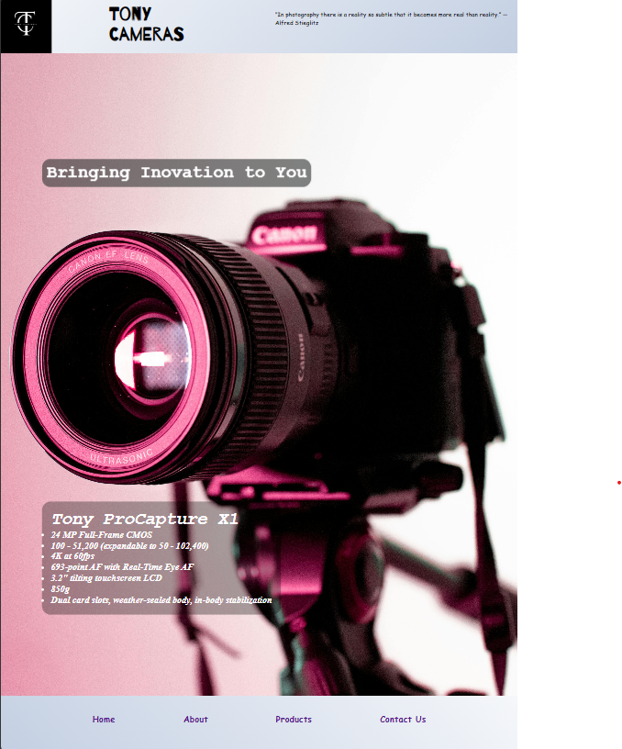

Desktop:  
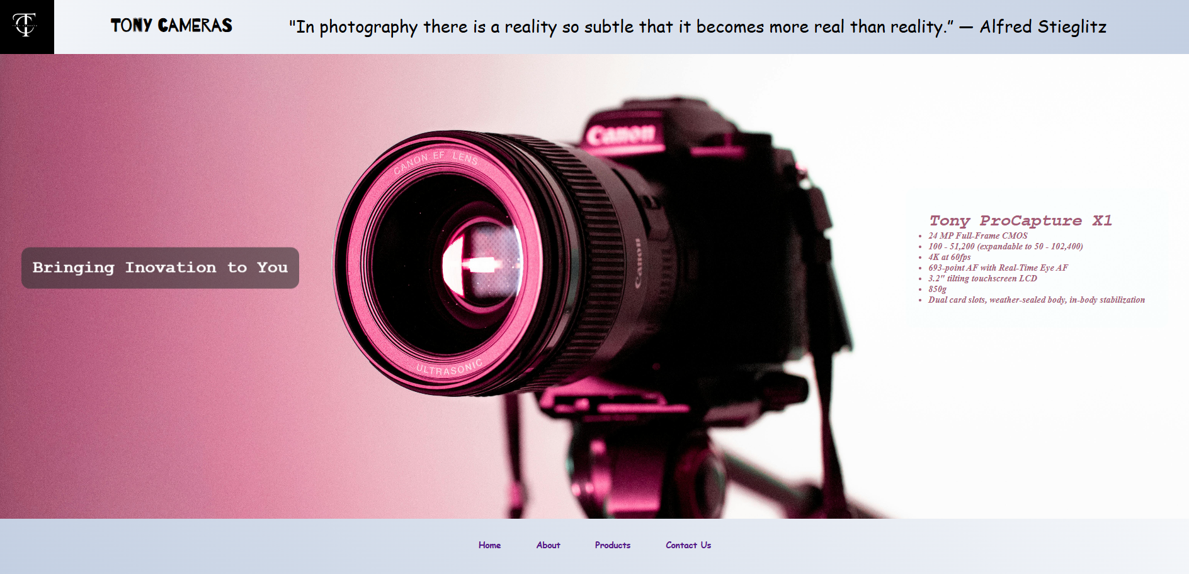

### 

About page:

Desktop

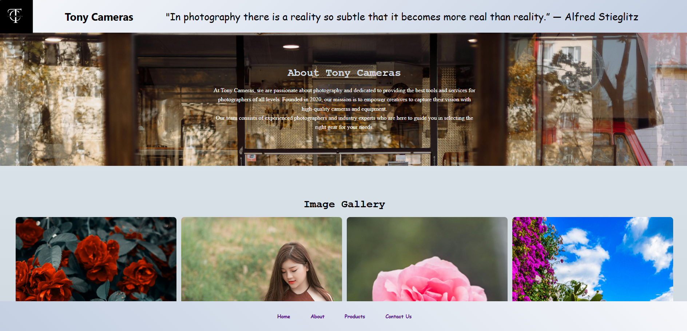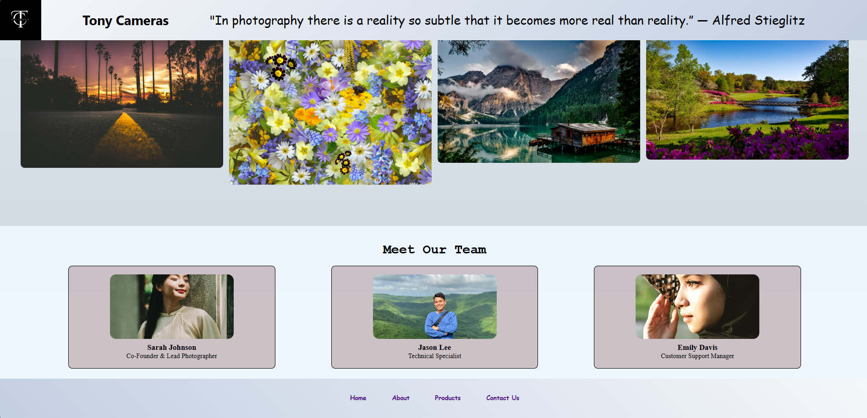

Tablet:

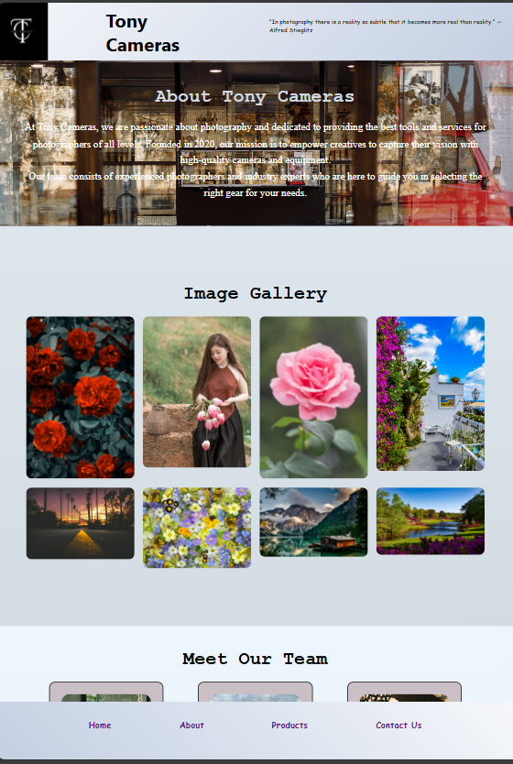

Mobile

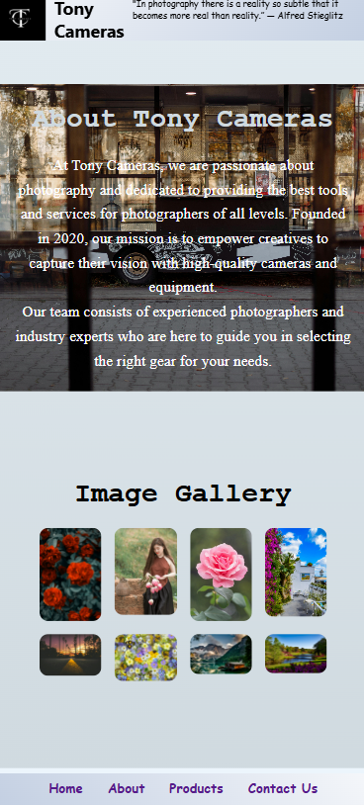

Contact Page:  
Mobile:  
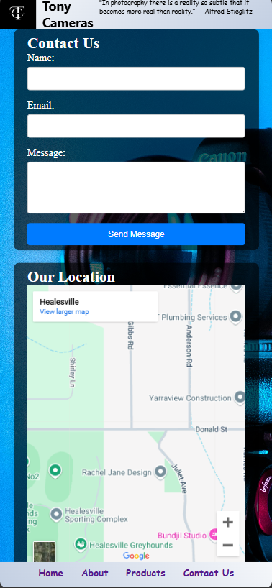

Tablet:  
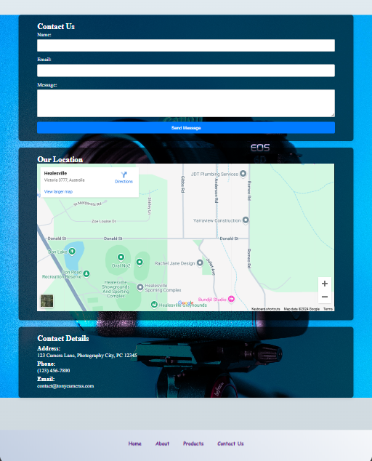

Desktop:  
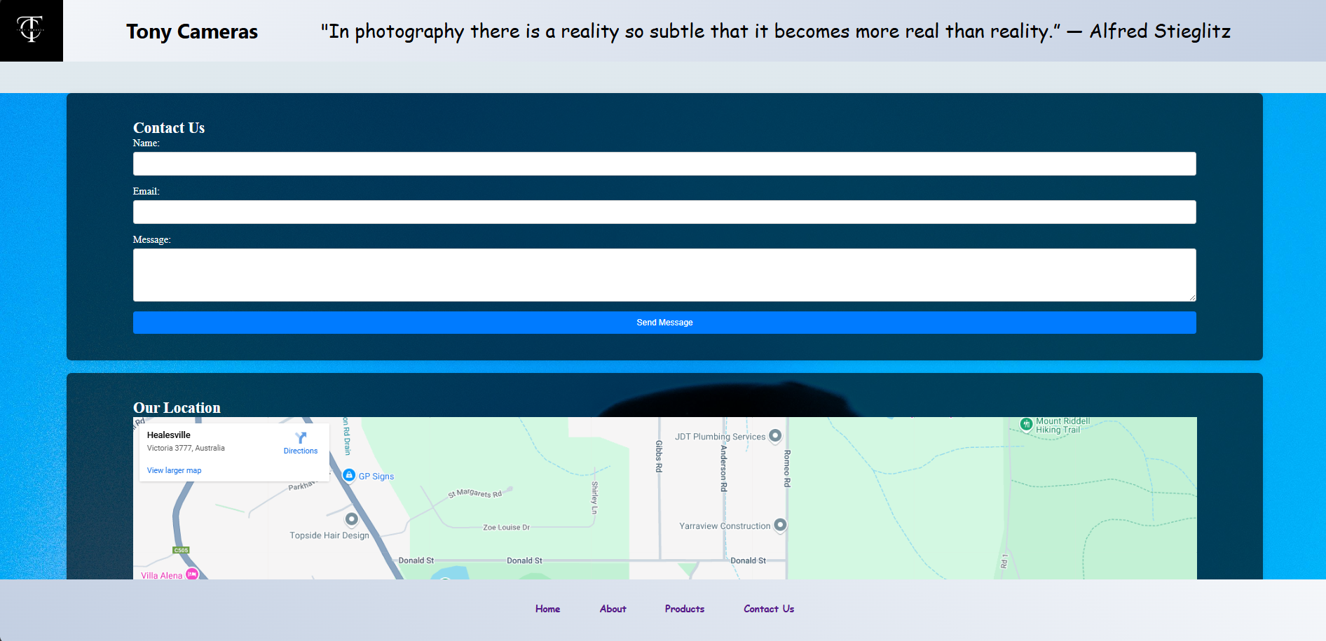

Product page

Desktop:  
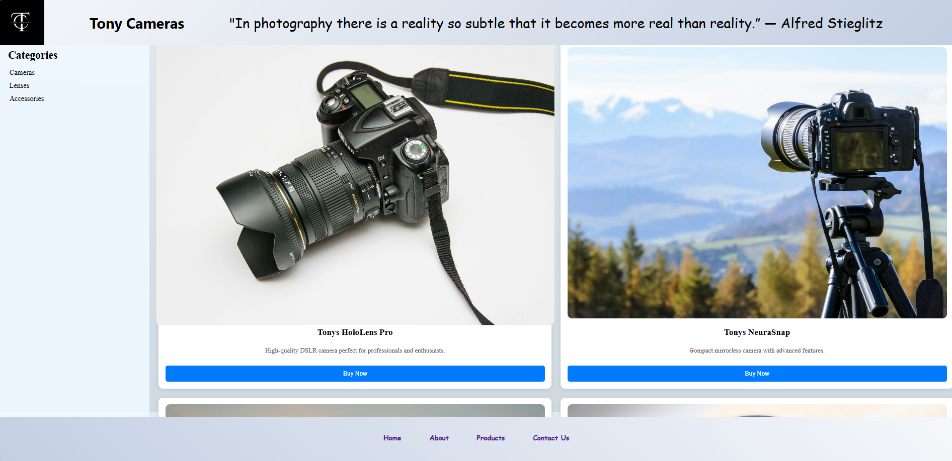

Mobile:  
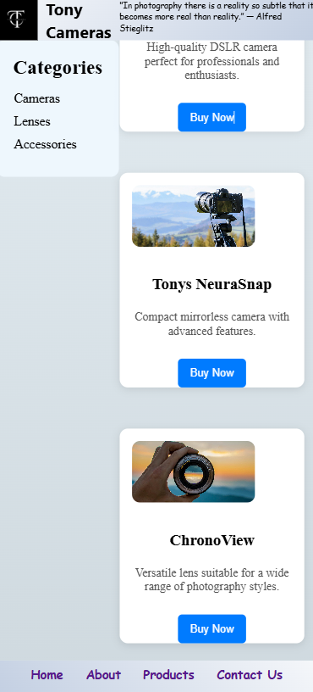

Tablet:  
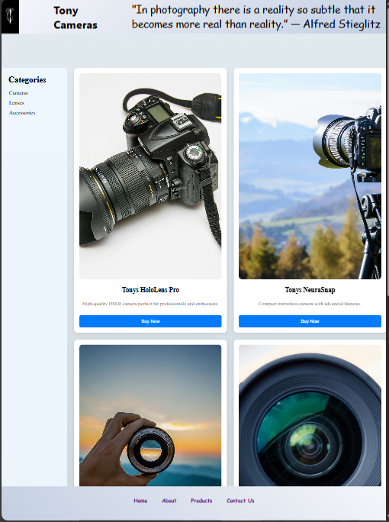

## **Explanation of Design Choices Made**

### **1. Use of Grid and Flexbox**

* **Grid Layout**: Implemented primarily in the product list and service sections to create a clean, structured layout that easily adapts to screen size.
* **Flexbox**: Utilized to align items within the hero section and header to properly space and align.

### **2. Typography and Color Choices**

* **Font Choices**: Selected to reflect the creative nature of photography, with varying weights for hierarchy and readability.
* **Color Palette**: Soft gradients and background images enhance visual appeal while maintaining readability.

### **3. Responsiveness**

* **Media Queries**: Employed to adjust layouts, font sizes, and element arrangements
* **Accessible Navigation**: Designed for touch interaction on mobile devices, with appropriately sized buttons and links. I mainly changed the flex-direction for better navigation.

In conclusion, the integration of CSS Grid Layout and responsive design principles creates an engaging, user-friendly website that adapts seamlessly to various devices. This approach not only enhances usability but also supports the aesthetic goals of the Tony Cameras brand.